Would you Be-Leave It?
Leave Your Leaves Curriculum, 9-12: Lesson 4 plan and activities

NC Essential Standards:

- Bio.1.11 Summarize the structure and function of organelles in eukaryotic cells (including the nucleus, plasma membrane, cell wall, mitochondria, vacuoles, chloroplasts, and ribosomes) and ways that these organelles interact with each other to perform the function of the cell.
- Bio.2.1.2 Analyze the survival and reproductive success of organisms in terms of behavioral, structural, and reproductive adaptations.

Objectives:

- Review the process of photosynthesis and the structure of the chloroplast
- Describe how the structure of a leaf serves as an adaptation to help a plant species survive.

Required materials

- Examples of leaves of a variety of types (the attached document has pictures, although real specimens would be even better. You can find lots of examples in the woods near your school or at a local nursery/home improvement center.
- Internet access to do research on climates where plants are found

Vocabulary: photosynthesis, chloroplast, evergreen, deciduous, adaptation, evolution
Leave Your Leaves Lesson 4
Would you Be-Leave It? Student Worksheet

- Generally, we think of leaves as what plants use for photosynthesis. What function does photosynthesis serve?

- Which organelle is the site of photosynthesis?

- Make a simple sketch of this organelle and label the following parts: stroma, thylakoids, lumen, granum, inner membrane, outer membrane.

- How does this organelle work with other organelles in plant cells to help the plant survive?

- Over time, though, plant species, have adapted so that the shapes of their leaves help them to survive in their particular environments. Look at the pictures of the various plant species below, and answer the questions about how their leaf shape helps them to thrive in their environment.

Plant Species | Describe the Shape of the Leaf | Climate(s) Where These Plants are Native? | How Leaf Adaptation  Helps Species to Survive
Virginia pine

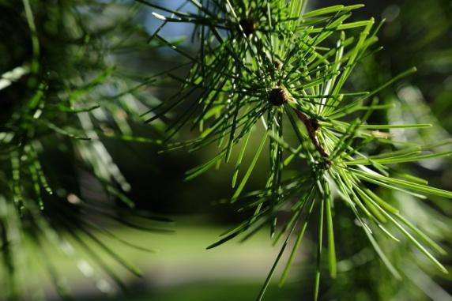

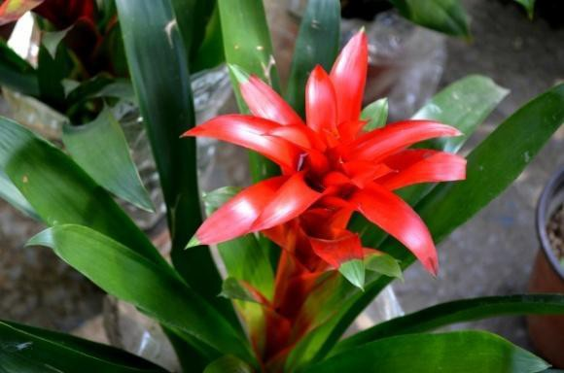
Guzmania Bromeliad
Venus flytrap

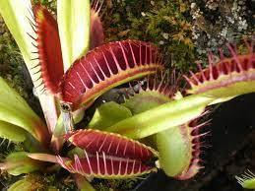

Beech

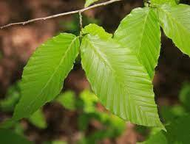

Saguaro cactus

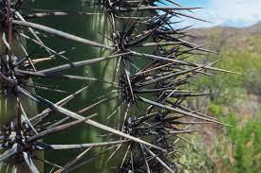

- What evolutionary advantage might there be for a plant to

  - be evergreen?
  - be deciduous?

- Pick one of the leaf times from above, and describe how it could have evolved. Think about what you know about natural selection.

